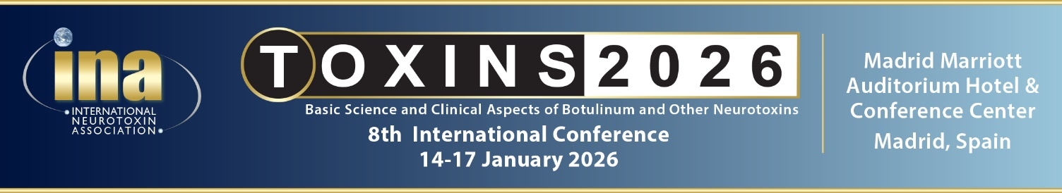
Schedule - Important Due Dates
Item | Information | Submit To: | Deadline Date
Company logo and description | Located on TOXINS 2026 website pages and app | Rose.puleo@neurotoxins.org | 20 October
Certificate of Insurance | Provided to Madrid Marriott Auditorium | Rose.puleo@neurotoxins.org | 20 October
Abstract Submission | Clinical and Basic Science Abstracts | https://www.neurotoxins.org/toxins-2026/abstract-submission/ | 24 October
Scanners for Booth | Handheld Scanners  $400 for 2 scanners  $250 for 1 scanner | Rose Puleo  Rose.puleo@neurotoxins.org | 10 November
Exhibit Booth Design | Exhibit booth design and measurements for approval and authorization | Ivan Pimienta  exhibits@neurotoxins.org | 14 November
Industry Sponsored Session | Session description and speakers for approval | Lisa.gottlieb@scientiae.com  Rose.puleo@neurotoxins.org | 14 November
Exhibit Booth | Description of exhibit booth activities and materials (except of company literature) | Lisa.gottlieb@scientiae.com  Rose.puleo@neurotoxins.org | 14 November
Industry Session Signage | 4 pull ups | Lisa.gottlieb@scientiae.com  Rose.puleo@neurotoxins.org | 1 December
Industry Sponsored Session Website Page | Logos, invitation, photos and/or videos | Lisa.gottlieb@scientiae.com  Rose.puleo@neurotoxins.org | 2 December  Page goes live  8 December
Advertisement on App | Advertising Materials | Lisa.gottlieb@scientiae.com  Rose.puleo@neurotoxins.org | 2 December
Branding | Authorized hotel space | Lisa.gottlieb@scientiae.com  Rose.puleo@neurotoxins.org | 2 December
Exhibit Booth Shipping and Materials | Madrid Marriott Auditorium Hotel & Conference Center  Avda. de Aragón 400  28022 Madrid (ESPAÑA) | Alejandro Alvarez  alejandro.alvarez@marriottauditorium.com  +34914004475  Conventions & Congress Coordinator of the event | See attachment

Exhibit Hours – Setup and Breakdown

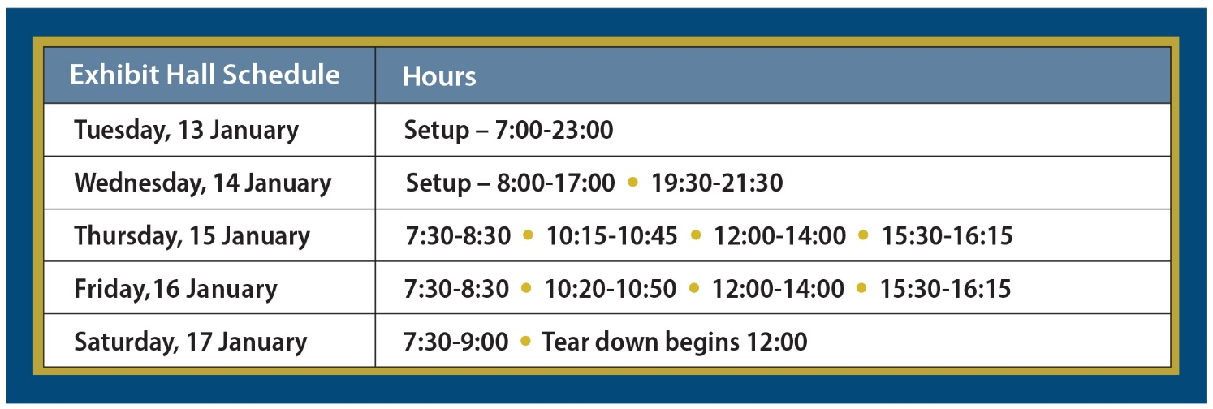
Tabletop exhibitors are provided with one 6-foot table, skirting, 2 chairs and a wastepaper basket

Industry Sponsored Sessions Webpage and App Specs

App Advertisement - 1 page four color ad
*Industry sponsored session webpage – Flyer/invitation to your session (videos accepted)

Specs for Advertisement on App:
- 1500 X 2000 Pixels
- EPS or PDF formats - all images and fonts embedded
- TIFF or JPEG formats at 1200 ppi with no compression applied

Spec for Webpage
- 8.5 x 11 single page
- EPS or PDF formats - all images and fonts embedded
- TIFF or JPEG formats at 1200 ppi with no compression applied

*Includes 2 app push notifications

Signage
A total of 4 pull ups - 2 pull ups on the stage for the industry sponsored session (Logo only). 2 pullups promoting your session. Please send signage for approval by Monday, December 1st. We will place the signage.

TOXINS 2026 Ancillary Events
Ancillary events are restricted during conference hours.

Thursday, 15 January – No ancillary events
- 18:15 – 19:15 - INA Business Meeting
- 19:15 - Faculty Dinner (No Faculty)
- 19:30 - 21:30 - Evening Industry-Sponsored Session

Time slots approved for HCP One-on-One sessions

Wednesday, 14 January  - Before 17:00 (5:00 pm)  - After 21:30 (9:30 pm) | Friday, 16 January  - 10:20-11:00  - 12:00-14:00  - 15:30-16:15  - After 17:45
Thursday, 15 January  - 10:15-10:55  - 12:15-14:15  - 15:50-16:20  - After 21:30 | Saturday, 17 January  - Before 9:00  - After 12:00

Contacts at the Madrid Marriott:
Alejandro Alvarez alejandro.alvarez@marriottauditorium.com and Laura Sanchez laura.sanchez@marriottauditorium.com

